

**Artificial Intelligence and Data Science Department.**

MP / Even Sem 2021-22 / Experiment 7.

YASH SARANG.

47 / D6AD.

EXPERIMENT - 7.

**____________________________________________________________**

**AIM:** Assembly program to sort numbers in ascending/ descending order.

**____________________________________________________________**

**THEORY:**

Problem – Write a program in 8086 microprocessor to sort numbers in ascending order in an array of n numbers, where size “n” is stored at memory address 2000 : 500 and the numbers are stored from memory address 2000 : 501.

Example –

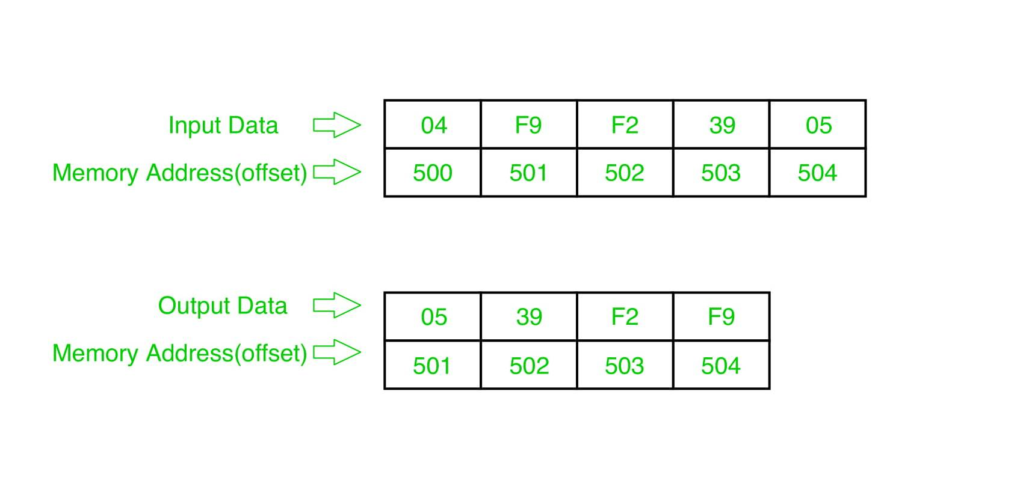

Example explanation:

Pass-1:

F9 F2 39 05

F2 F9 39 05

F2 39 F9 05

F2 39 05 F9 (1 number got fix)

Pass-2:

F2 39 05 F9

39 F2 05 F9

39 05 F2 F9 (2 number got fix)

Pass-3:

39 05 F2 F9

05 39 F2 F9 (sorted)

Algorithm –

1. Load data from offset 500 to register CL (for the count).
2. Travel from starting memory location to last and compare two numbers if the first number is greater than the second number then swap them.
3. First-pass fix the position for the last number.
4. Decrease the count by 1.
5. Again travel from starting memory location to (last-1, with the help of count) and compare two numbers if the first number is greater than the second number then swap them.
6. The second pass fixes the position for the last two numbers.
7. Repeated.

**____________________________________________________________**

**Program 1:**

| MEMORY ADDRESS | MNEMONICS | COMMENT |
| --- | --- | --- |
| 400 | MOV SI, 500 | SI<-500 |
| 403 | MOV CL, [SI] | CL<-[SI] |
| 405 | DEC CL | CL<-CL-1 |
| 407 | MOV SI, 500 | SI<-500 |
| 40A | MOV CH, [SI] | CH<-[SI] |
| 40C | DEC CH | CH<-CH-1 |
| 40E | INC SI | SI<-SI+1 |
| 40F | MOV AL, [SI] | AL<-[SI] |
| 411 | INC SI | SI<-SI+1 |
| 412 | CMP AL, [SI] | AL-[SI] |
| 414 | JC 41C | JUMP TO 41C IF CY=1 |
| 416 | XCHG AL, [SI] | SWAP AL AND [SI] |
| 418 | DEC SI | SI<-SI-1 |
| 419 | XCHG AL, [SI] | SWAP AL AND [SI] |
| 41B | INC SI | SI<-SI+1 |
| 41C | DEC CH | CH<-CH-1 |
| 41E | JNZ 40F | JUMP TO 40F IF ZF=0 |
| 420 | DEC CL | CL<-CL-1 |
| 422 | JNZ 407 | JUMP TO 407 IF ZF=0 |
| 424 | HLT | END |

Explanation –

1. MOV SI, 500: set the value of SI to 500.
2. MOV CL, [SI]: load data from offset SI to register CL.
3. DEC CL: decrease the value of register CL BY 1.
4. MOV SI, 500: set the value of SI to 500.
5. MOV CH, [SI]: load data from offset SI to register CH.
6. DEC CH: decrease the value of register CH BY 1.
7. INC SI: increase value of SI BY 1.
8. MOV AL, [SI]: load value from offset SI to register AL.
9. INC SI: increase the value of SI BY 1.
10. CMP AL, [SI]: compares value of register AL and [SI] (AL-[SI]).
11. JC 41C: jump to address 41C if carry generated.
12. XCHG AL, [SI]: exchange the contents of register AL and SI.
13. DEC SI: decrease the value of SI by 1.
14. XCHG AL, [SI]: exchange the contents of register AL and SI.
15. INC SI: increase the value of SI by 1.
16. DEC CH: decrease the value of register CH by 1.
17. JNZ 40F: jump to address 40F if zero flat resets.
18. DEC CL: decrease the value of register CL by 1.
19. JNZ 407: jump to address 407 if zero flat resets.
20. HLT: stop.

**____________________________________________________________**